MULTI-DISEASE PREDICTION USING MACHINE LEARNING
(An Intelligent Health Assistant for Diabetes, Heart, Liver and Kidney Risk)
Design and Implementation
Department of Computer Science and Engineering, TKR College of Engineering and Technology (Autonomous)
Batch A3 (CSE-A) · Academic year [ACADEMIC YEAR]
Table 1: Project team
S.No. | Student name | Roll number
1 | AJMEERA HARINI | 23K91A0507
2 | BANDI LIKITHA | 23K91A0526
3 | CHINTHAKINDI SWATHI | 23K91A0555
4 | BADROJU SRI HANSIKA | 23K91A0524

Project guide: B. SRUTHI, Faculty Project Guide, Department of CSE
Chapter and section numbers quoted in the text (for example Section 6.6 or Chapter 8) refer to the full project report, 17.Final Document. Figures and tables in this document are numbered from 1.

1. DESIGN

5.1 Design Principles
• One set of models, two front doors. The trained bundles and the field metadata live in app.py. The FastAPI service imports them instead of copying them, so the React interface and the original Flask pages cannot give different answers.
• Train offline, predict online. Training is a separate script that writes files; the web application only loads them. Nothing is trained while a user waits.
• Stateless prediction. A request carries every value it needs and the answer is computed and returned; nothing about the patient is stored or logged.
• Fail early and clearly. The form checks required and numeric fields; the API rejects a missing or non-finite value with a plain message (422) and an unknown disease with 404 before any model is called.
• Say what the data is. The Datasets page, the About page and the result card state that the training data is synthetic and that the output is not a diagnosis.

5.2 System Architecture
The figure separates an offline pipeline from the online application. Offline, generate_data.py writes the four CSV files in data/, and train_models.py reads them and writes twelve pickle files (model, scaler and feature list for each disease) and training_report.json into models/. Online, run.bat starts the FastAPI service on port 8303 and the React application on port 5303; the React application calls the API with JSON over HTTP, the API imports app.py (which loads the pickles at start-up and holds the field metadata), and app.py calls scikit-learn for scaling and prediction. The API also reads the CSV files for the sample rows and dataset counts. The original Flask pages on port 5000 use the same bundles and the same arithmetic. The footnote states the main design fact: there is no SQL database, no authentication and no stored patient data.
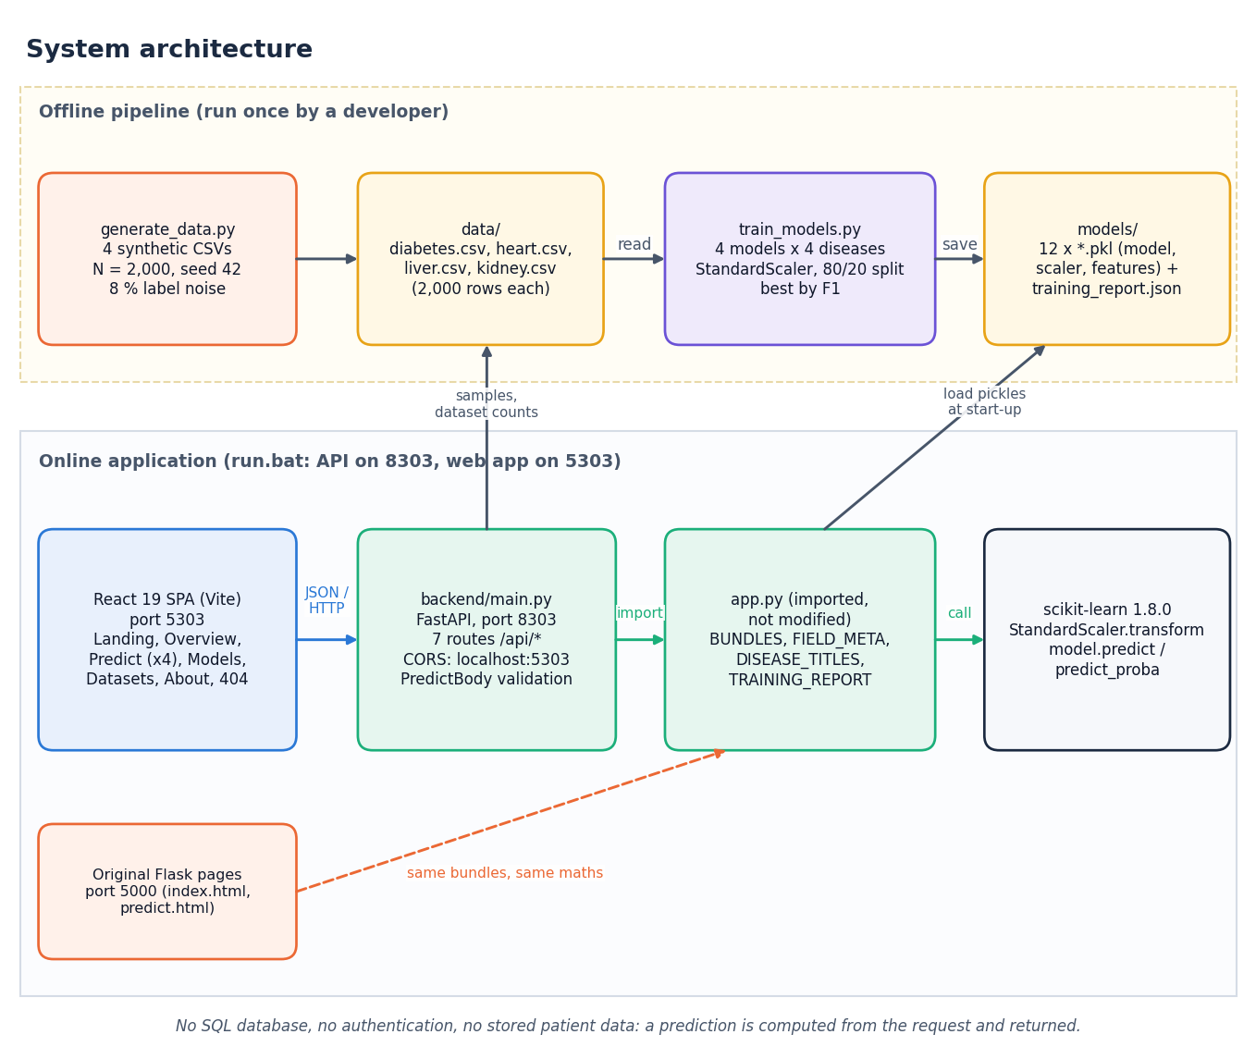
Figure 1: System architecture of the Intelligent Health Assistant
The Python code that makes the system work is small: 694 lines in the four core files (generate_data.py, train_models.py, app.py, backend/main.py), 1,849 lines in the test, measurement and documentation scripts, and about 5,487 lines in the React interface. The FastAPI layer was added for the web interface and leaves app.py unchanged.

5.3 High-Level Workflow
Eight steps in two rows. Steps 1 to 3 (generate data, train and compare, select and save) are offline and are repeated only to regenerate the data or retrain. Steps 4 to 8 happen at run time: the API loads the bundles, the user chooses a disease, enters values or loads a real sample row, the API validates, scales and predicts, and the interface shows the class, the confidence, the model and its hold-out accuracy.
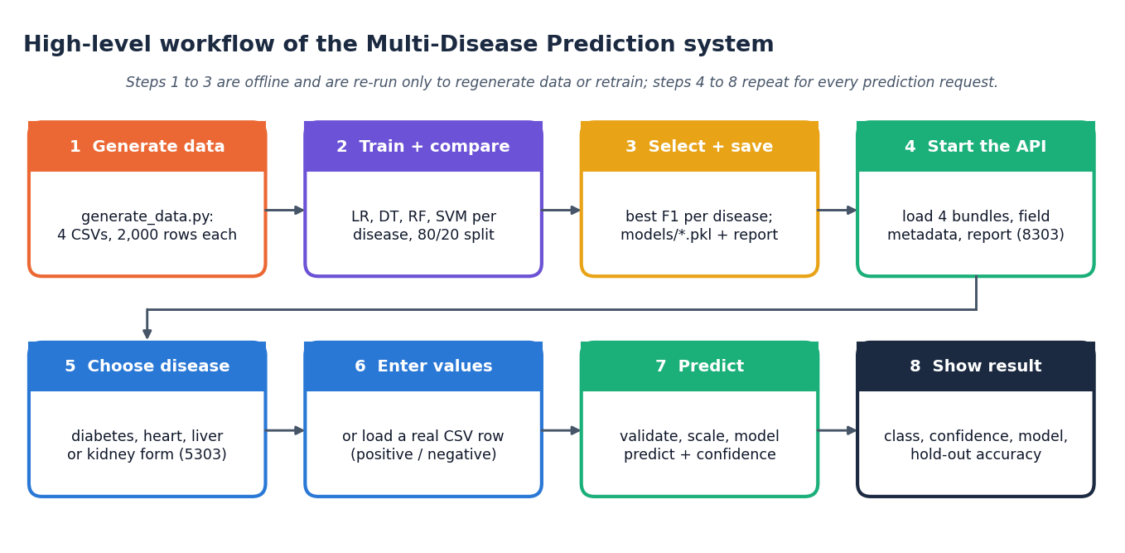
Figure 2: High-level workflow of the system

5.4 Module Design
Table 2: Modules and what each is responsible for
Module | Lines | Responsibility
generate_data.py | 213 | Draws four synthetic clinical datasets (2,000 rows each, numpy seed 42): feature distributions, a linear risk score per disease, a sigmoid, a 0.5 threshold and 8% label flipping (add_noise_labels)
train_models.py | 122 | For each disease: stratified 80/20 split, StandardScaler fitted on the training part, four classifiers (MODEL_BUILDERS), accuracy / precision / recall / F1, selection of the model with the highest F1, joblib.dump of model, scaler and feature list, training_report.json
app.py | 162 | Original Flask application: loads the three pickles of each disease into BUNDLES, holds FIELD_META (label, placeholder, input type of every feature), DISEASE_TITLES and TRAINING_REPORT; routes /, /diabetes, /heart, /liver, /kidney; handle_prediction()
backend/main.py | 197 | FastAPI service that imports app.py (without modifying it) and exposes seven JSON routes; builds form metadata (_fields, _options) from FIELD_META and the CSV ranges; validates the request and predicts with the same steps as handle_prediction()
templates/ and static/ | 321 | The two Jinja2 templates (index.html, predict.html) and the stylesheet of the original Flask pages
frontend/src/ | 5,487 | React 19 single-page application: App.jsx (routes), pages/ (Landing, Overview, Predict, Models, Datasets, About, NotFound), lib/api.js (the only network layer), components/ui (design-system components), components/charts (Recharts), components/three (landing-page 3-D hero)
scripts/ | 1,849 | smoke_test.py, api_tests.py, run_experiments.py, real_data_check.py, capture_screens.py, capture_extra.py, make_diagrams.py, make_figures.py and the documentation builders in scripts/docs/

backend/main.py contains thirteen functions: seven route handlers (health, diseases, disease, sample, predict, report, datasets), the request model PredictBody, and five helpers (_best, _options, _fields, _summary, _check). _fields builds the form description of a disease from FIELD_META and from the minimum, maximum and median of each column of its CSV; _options turns labels such as "Sex (1 = Male, 0 = Female)" into drop-down options, or, for integer columns with at most six distinct values, into a list of those values.

5.5 Data Flow
One process, the Multi-Disease Prediction System, exchanges data with two external entities. The user sends a disease choice, patient values or a sample request and receives a risk class, a confidence, the model and its accuracy, and metrics and dataset facts. The developer runs the data generator and the training script and receives the training report. Two data stores are used: D1, the four CSV files, and D2, the pickle files and the training report.
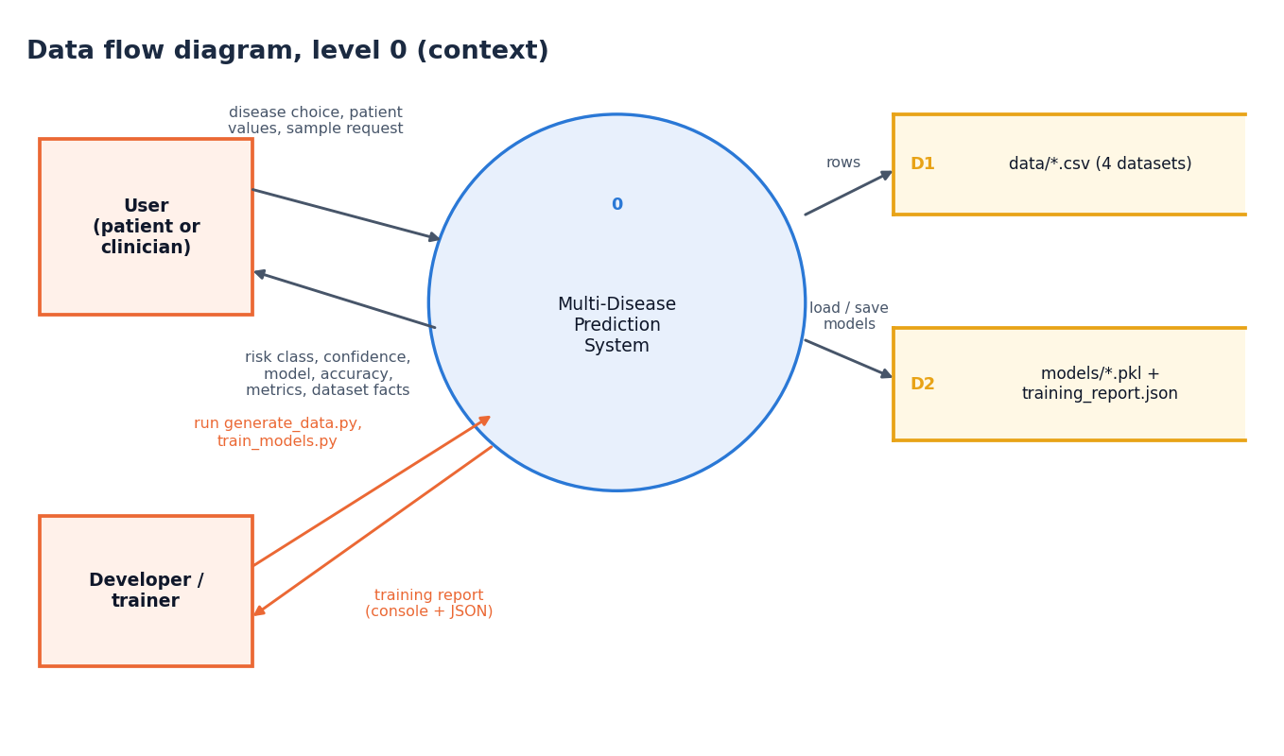
Figure 3: Data flow diagram, level 0 (context)
The system is decomposed into four processes. Process 1.0 generates the datasets and writes them to D1. Process 2.0 reads D1, trains and selects the models and writes the bundles and report to D2. Process 3.0 serves form metadata, metrics and sample rows to the user from D1 and D2. Process 4.0 receives a disease and patient values from the user, reads the bundle from D2 and returns the risk class, confidence, model and accuracy.
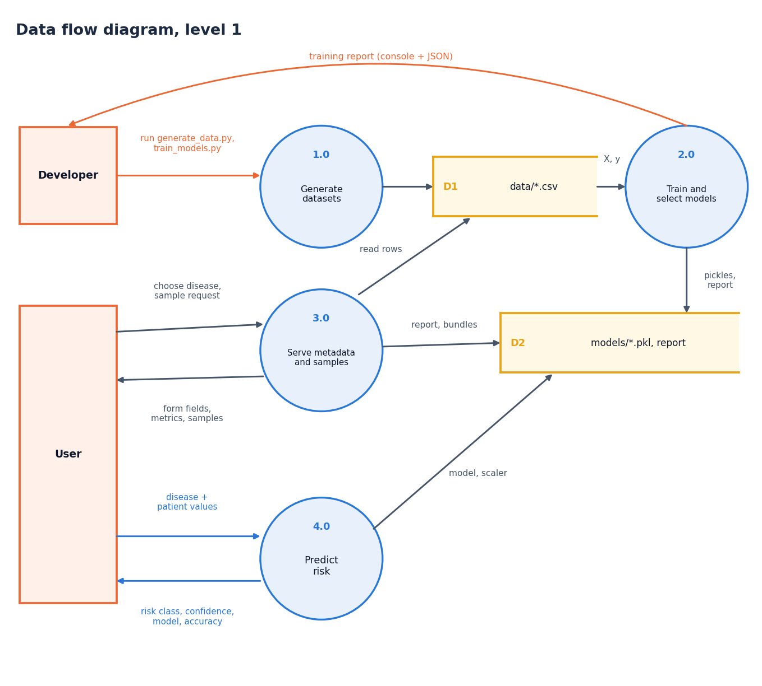
Figure 4: Data flow diagram, level 1
Process 4.0 expands into five sub-processes: 4.1 validates the disease key (an unknown key returns 404 to the user), 4.2 converts every value to a finite number in the saved feature order (a missing or non-finite value returns 422), 4.3 scales the vector with the saved StandardScaler, 4.4 predicts the class and the class probabilities with the saved model, and 4.5 formats the JSON result. Processes 4.2 to 4.4 read the feature order, the scaler and the model from the D2 bundle. The footnote records that validation happens twice: in the React form and again in the API.
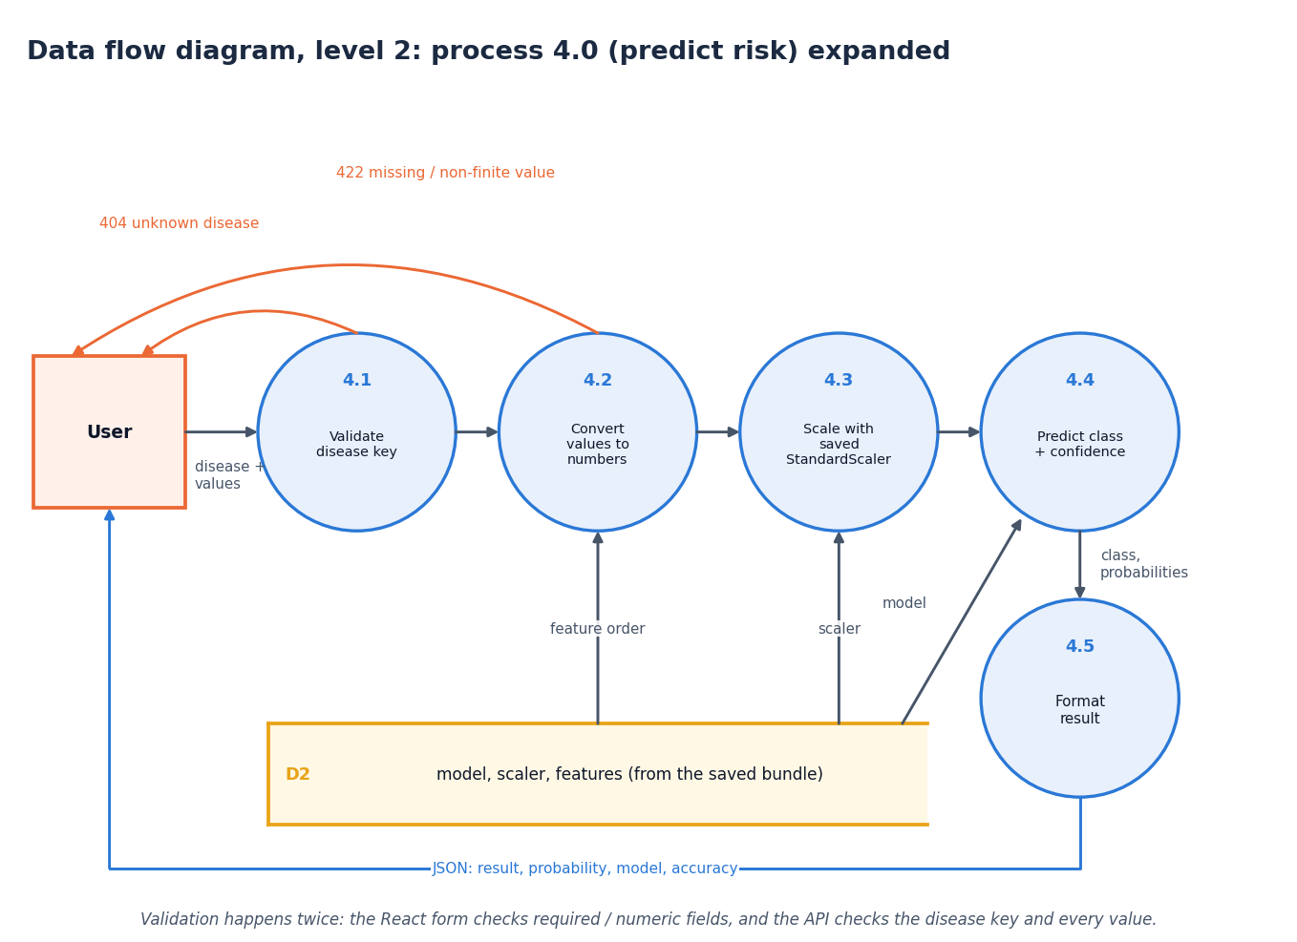
Figure 5: Data flow diagram, level 2: process 4.0 (predict risk) expanded

5.6 Class, Sequence and Use-Case Design
The code base is function-oriented, so most boxes are modules or plain data structures drawn with a stereotype: the FastAPI routes of backend/main.py (with the PredictBody pydantic model), the Flask module app.py that holds TRAINING_REPORT, BUNDLES, FIELD_META and DISEASE_TITLES, the ModelBundle tuple (model, scaler, features), the training script, the data generator, and the four scikit-learn estimator classes with their constructor settings. Solid arrows mean uses or contains; dashed arrows mean writes files. The only real classes are the pydantic PredictBody and the scikit-learn estimators; no class was invented for the diagram.
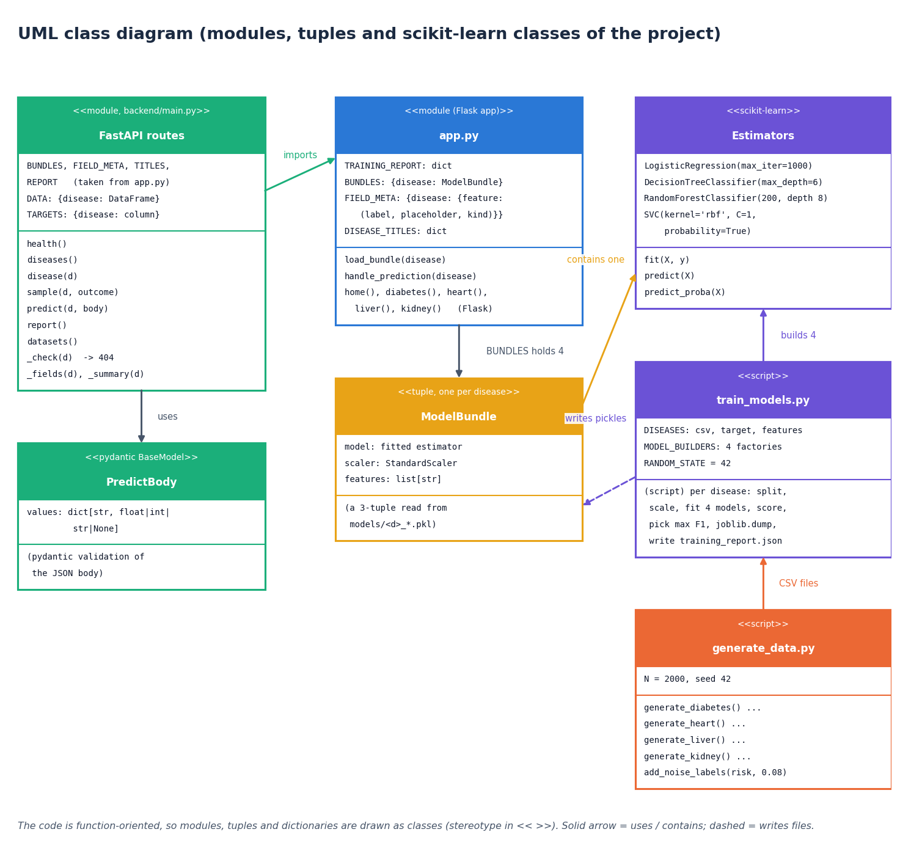
Figure 6: UML class diagram (modules, tuples and scikit-learn classes of the project)
The messages exchanged when a user opens the heart-disease page, loads a positive sample row and presses Predict risk. The React page fetches the field metadata, then the sample row, validates the form locally, and posts the values; the API checks the disease key, takes the bundle from app.py, converts the values, scales them, calls the model and returns the JSON result that the page shows as a result card. The footnote records that the API keeps no state between requests.
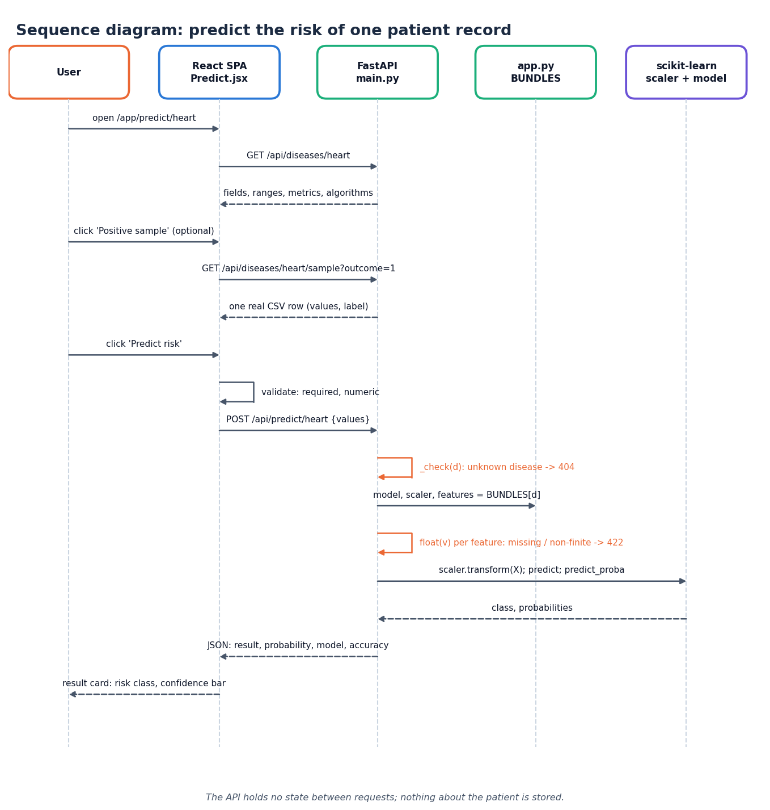
Figure 7: Sequence diagram: predict the risk of one patient record
Two actors and eleven use cases. The user can browse the landing page and overview, choose a disease, enter patient values, load a real sample record, predict disease risk (which includes validation of the input), view the model comparison, view the training datasets and read the about page. The developer can generate the synthetic datasets, train and select the best models and run the smoke test of the API. There is no sign-in: every user sees every screen, and predicting needs the models that the developer use cases create.
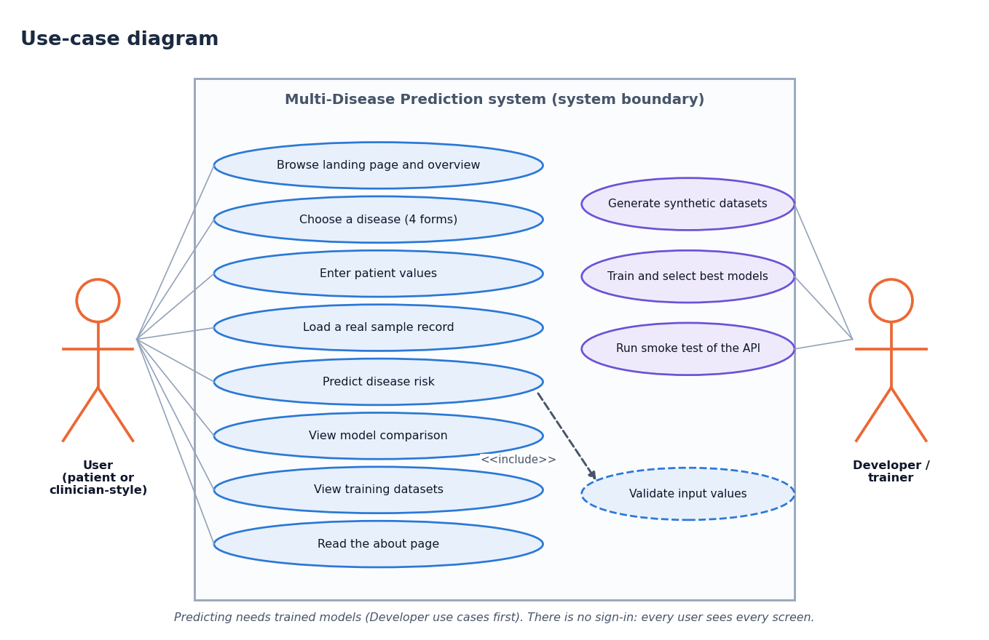
Figure 8: Use-case diagram

5.7 Database Design (Logical Data Model)
The project has no database, so this is the logical data model of the artefacts the code handles. A DISEASE has one DATASET_CSV, many FEATUREs (the form inputs), one MODEL_BUNDLE (model, scaler and feature-list pickles plus the name of the best model), four ALGORITHM_RESULTs (the metrics of the four algorithms in training_report.json) and many PREDICTIONs; a PREDICTION is transient and exists only for the duration of one request.
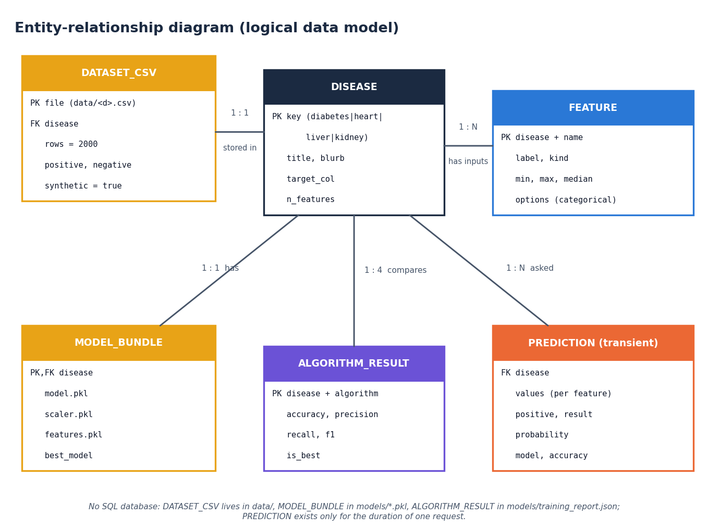
Figure 9: Entity-relationship diagram (logical data model)
Table 3: Entities of the logical data model
Entity | Where it lives | Key and content
DISEASE | Constants in train_models.py, app.py, backend/main.py | Key diabetes / heart / liver / kidney; title, blurb, target column, number of features
DATASET_CSV | data/<disease>.csv | 2,000 rows; 8, 13, 10, 12 feature columns (diabetes, heart, liver, kidney) plus a 0/1 target; synthetic
FEATURE | Headers of the CSV; FIELD_META in app.py | Name; label, placeholder and input type; minimum, maximum and median computed from the CSV; options for categorical inputs
MODEL_BUNDLE | models/<d>_model.pkl, _scaler.pkl, _features.pkl | The fitted best estimator, the fitted StandardScaler, the ordered list of feature names
ALGORITHM_RESULT | models/training_report.json | Per disease and algorithm: accuracy, precision, recall, F1 (4 decimals); name of the best model
PREDICTION (transient) | Request and response of one call | Disease, values per feature; result text, positive flag, probability, model, accuracy. Not stored

This is a file-based design chosen for simplicity: the data are small (8,000 rows in total), read-only at run time, and contain no personal information, so a database server would add operational cost and nothing else. The consequence is that nothing can be audited afterwards, because no prediction is recorded.

5.8 Algorithm Design
Panel A is the offline training loop of train_models.py: read the CSV of a disease, split 80/20 with stratification and seed 42, fit the StandardScaler on the training part, fit and score the four algorithms, keep the one with the highest F1, dump model, scaler and features, repeat for the next disease, and finally write the training report. Panel B is the online prediction of POST /api/predict/{d}: check the disease key (404), convert every feature to a float and check that it is finite (422), scale, predict, derive the class and the confidence, and return the JSON.
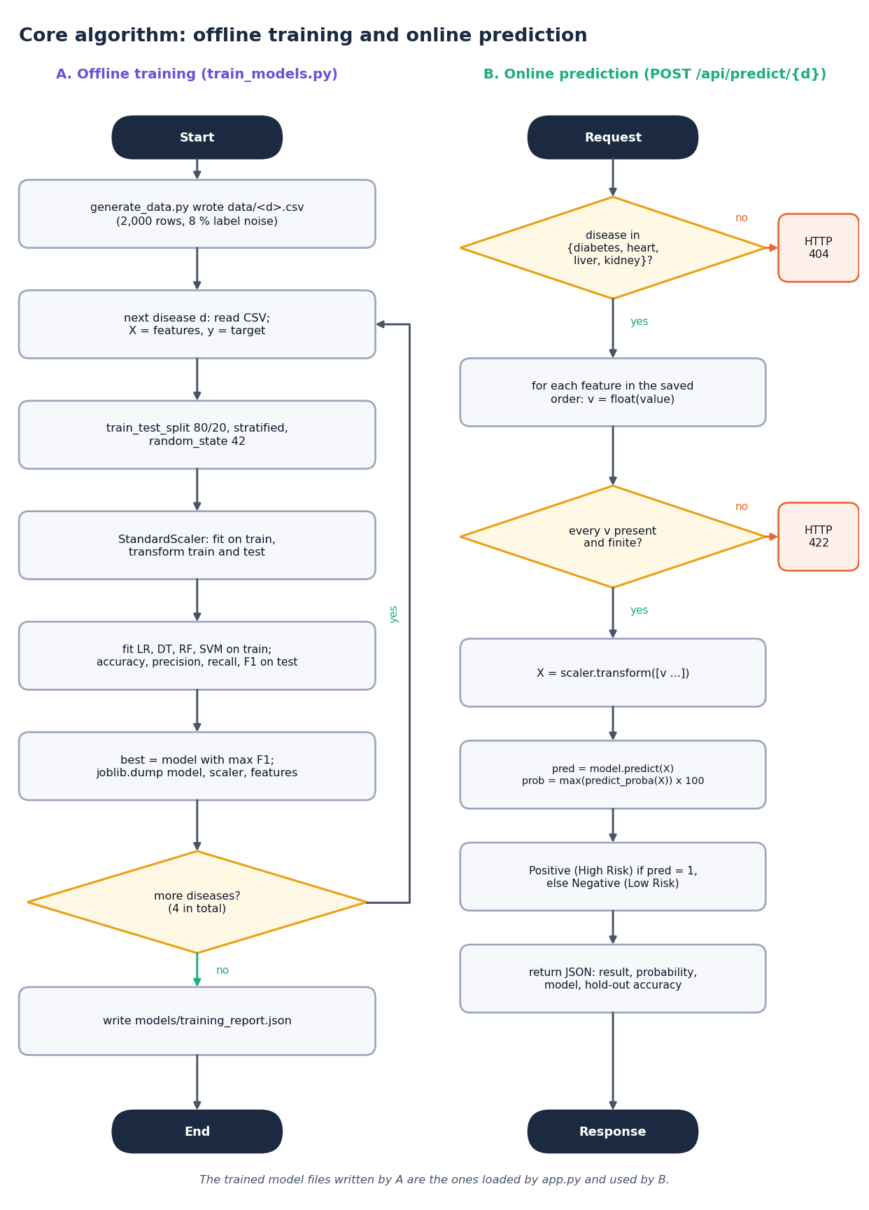
Figure 10: Flowchart of the core algorithm: offline training and online prediction
Chapter 6 gives each step in detail. Two design decisions are worth stating here. First, the model is selected on F1, not on accuracy, because several of the classes are unbalanced (for example only about 28% of the liver rows and 41% of the diabetes rows are positive). Second, the selection is made on the same 400-row test set that is then reported; this is simple but makes the reported number of the winner slightly optimistic, and Chapter 8 shows with cross-validation and ten random splits that it also picked a model for diabetes that the repeated evidence does not support.

5.9 API Design
The API follows REST conventions: nouns in paths, GET for reads and POST for the one action that computes. Responses are JSON; errors carry a plain-language detail field. FastAPI generates interactive documentation at /docs. Three status codes are used by the application code: 404 for an unknown disease, 422 for a request whose values are missing or not finite numbers (and for malformed JSON, which pydantic rejects), and 200 otherwise. Cross-origin requests are allowed only from http://localhost:5303 and http://127.0.0.1:5303, the origins of the React application.
Table 4: The seven routes of backend/main.py
Method | Path | Purpose
GET | /api/health | Liveness; returns the four disease keys
GET | /api/diseases | Summary of each condition: best model, accuracy, F1, number of features
GET | /api/diseases/{d} | Form fields (label, type, min, max, median, options), metrics of the best model, scores of all four algorithms
GET | /api/diseases/{d}/sample?outcome=0|1 | One random real row of data/<d>.csv, optionally of a given label, to pre-fill the form
POST | /api/predict/{d} | Body {"values": {...}}; returns class, confidence, model and accuracy; 422 for a missing or non-finite value, 404 for an unknown disease
GET | /api/report | The complete training_report.json
GET | /api/datasets | Rows, class balance, feature list and a synthetic: true flag for every CSV

5.10 State and Persistence Design
The API process holds four read-only structures built once at start-up: BUNDLES (the four model bundles, loaded by app.py), FIELD_META, REPORT (the parsed training report) and DATA (the four CSV files as pandas data frames, used for the sample rows, the field ranges and the dataset counts). No request changes any of them, which is why the service is safe to run with several worker threads and why a restart changes nothing. The only things written to disk are written by the training script: twelve pickle files and one JSON file.

5.11 Security Design
• There is no authentication, authorisation or session: every visitor can use every route. This is acceptable for a local demonstration of a model and would not be acceptable for a service handling real patients.
• No patient data is stored, logged by the application code or sent to any external service; the prediction is returned to the caller only.
• The API accepts only JSON bodies of the form {"values": {...}} (validated by pydantic) and converts every value with float(), rejecting nan and infinity; unknown extra fields are ignored.
• CORS is restricted to the two origins of the React application (Section 5.9).
• The original Flask application starts with debug=True and host="0.0.0.0" (app.py). That is convenient in development but exposes the Werkzeug debugger to the local network; it should not be used outside a development machine and was not changed in this project.
• Model files are unpickled with joblib.load. Pickle files from an untrusted source can execute code, so models/ must only ever contain files produced by train_models.py.

5.12 User-Interface Design
The React interface has a landing page with a three-dimensional hero, an overview page, one prediction page per disease (the four forms share one component, Predict.jsx, driven by the metadata returned by the API), a model-comparison page, a dataset page, an about page and a not-found page. It has dark and light themes, a collapsible sidebar on small screens, and a status badge that polls /api/health every 30 seconds so that the interface says honestly when the API is not running. Each prediction form offers two buttons, Positive sample and Negative sample, that load a real row of the CSV (which does not mean the model will agree with that row's label), shows the training range under every numeric field and warns when a value is outside it, and marks missing fields as Required. The result card shows the risk class, a confidence bar, the condition, the model used, that model's hold-out accuracy and a not-a-diagnosis notice.
The layout was checked at a phone width of 390 px as well as at 1440 px; the sidebar becomes a menu and the form fields stack in one column. The overview, validation-error and phone-layout screens are shown as Figures in Chapter 8 (Section 8.12).
The prediction and result screens, the model comparison and the dataset page are shown with their data in Chapter 8 and in Appendix C.

2. IMPLEMENTATION

6.8 Application Architecture
The application has three layers that share one set of trained models. The model layer is the offline script train_models.py and the files it writes in models/. The service layer is app.py, which loads those files once at import time into BUNDLES (a dictionary from disease key to the tuple model, scaler, features) and defines FIELD_META, and backend/main.py, a FastAPI application that imports app.py and adds the JSON routes. The presentation layer is the React application in frontend/. Because backend/main.py imports the Flask module instead of copying its objects, the API and the original Flask pages use the identical models and the identical arithmetic; importing app.py does not start the Flask server.
The React application is a single-page application built with Vite. src/App.jsx declares the routes (the landing page, then /app with an overview, predict/:disease, models, data, about and a not-found page; all but the landing page are loaded lazily). src/lib/api.js is the only place that talks to the network: it prefixes every path with the API address (VITE_API_URL, default http://127.0.0.1:8303), turns a failed fetch into the message "Cannot reach the prediction API", and turns a non-200 answer into an error carrying the detail text of the API. Predict.jsx is one component for all four diseases: it asks /api/diseases/{d} for the fields, renders a number input or a drop-down for each, validates that every field is filled with a number, posts {"values": {...}} and shows the answer. Page data are loaded with a small useAsync hook, and the connection badge uses useHealth, which polls /api/health every 30 seconds.

6.9 API Design with Real Requests and Responses
The seven routes are listed in Chapter 5. The following exchanges were captured from the running service on 127.0.0.1:8303. A prediction request carries one value for each feature, keyed by the feature name:
POST /api/predict/diabetes
{"values": {"Pregnancies": 2, "Glucose": 128.9, "BloodPressure": 71.8, "SkinThickness": 32.4,
"Insulin": 103.3, "BMI": 30.2, "DiabetesPedigreeFunction": 0.93, "Age": 54}}

200 OK
{"disease": "diabetes", "title": "Diabetes Risk Prediction", "positive": true,
"result": "Positive (High Risk)", "probability": 90.71, "model": "SVM", "accuracy": 0.895}

A request with a value that is not a number is refused before the model is called; the message names the labels of the fields that failed. Here only Glucose was sent (with the text "abc"), so all eight labels are listed:
POST /api/predict/diabetes {"values": {"Glucose": "abc"}}

422 Unprocessable Entity
{"detail": "Please enter a valid number for: Number of Pregnancies, Glucose Level (mg/dL),
Blood Pressure (mm Hg), Skin Thickness (mm), Insulin Level (mu U/ml), BMI,
Diabetes Pedigree Function, Age."}

The sample route returns a real row of the CSV and its label, which the interface uses to fill the form:
GET /api/diseases/kidney/sample?outcome=1

200 OK
{"values": {"age": 49.0, "blood_pressure": 89.7, "specific_gravity": 1.005, "albumin": 2.0, "sugar": 2.0,
"blood_glucose_random": 151.5, "blood_urea": 64.5, "serum_creatinine": 0.84, "sodium": 142.6,
"potassium": 3.48, "hemoglobin": 10.74, "packed_cell_volume": 31.5},
"label": 1}

GET /api/diseases/{d} returns the data the form needs: for each field its name, label, placeholder, input type, minimum, maximum and median in the CSV, and the options of a categorical field (for example {"value": 1, "label": "Male"}), together with the metrics of the best model and the four algorithms' scores. GET /api/datasets returns, for every disease, the row count, the positive and negative counts, the target column, the feature list and "synthetic": true, which the Datasets page turns into its warning banner.
On the project machine a prediction request takes a median of 13.5 ms and a 95th percentile of 24.9 ms (200 calls on 127.0.0.1); Chapter 7 gives the measurements and their caveats.

6.10 Security and Error Handling
The application is built as a local demonstration, and its security posture is correspondingly limited. The facts are:
• No authentication and no stored data. Every route is open; no patient value is written to disk or to a log by the application, and the result exists only in the response.
• Input validation. The pydantic model PredictBody requires a JSON object values; each value is converted with float(), and a missing key, null, an empty string, text, nan or infinity is reported with HTTP 422 and a readable message. Unknown extra keys are ignored. Physiologically impossible numbers (a glucose of 100,000 mg/dL or an age of -5) are accepted, because there is no range check in the API; the interface only warns when a value lies outside the training range of the feature.
• Error codes. 404 for an unknown disease key (also for the detail and sample routes), 422 for invalid input or malformed JSON, 405 for a wrong method, 404 for an unknown route. The React client shows the detail text; if the API cannot be reached it says so.
• CORS. Only http://localhost:5303 and http://127.0.0.1:5303 may call the API from a browser.
• Model files. joblib.load is used on the files in models/; these must come only from train_models.py because pickle files can execute code when loaded.
• Flask development server. app.py runs with debug=True on all interfaces when started directly. This is for local use only.
What is missing, and would be required before any real use, is authentication and authorisation, transport security (HTTPS), rate limiting, audit logging, range validation of clinical values, and a data-protection review.

6.11 Installation and Execution
The project needs Python 3.11 or newer and Node.js (the project was built with Python 3.11.9 and Node 24). The trained models were saved with scikit-learn 1.8.0, so the pinned requirements.txt must be used: an older scikit-learn fails on predict_proba when it unpickles the models.
Table 5: Pinned Python packages (requirements.txt)
Package | Version | Used for
scikit-learn | 1.8.0 | Models, scaler, metrics
pandas | 3.0.2 | Reading the CSVs in the API
numpy | 2.4.4 | Arrays, data generation
joblib | 1.5.3 | Saving and loading the models
Flask | 3.1.3 | The original web pages and the shared app.py
fastapi | 0.110.0 | The JSON API
uvicorn | 0.29.0 | The ASGI server

On Windows the whole application starts with one command:
run.bat # creates venv\ and installs requirements.txt on first run, installs frontend\node_modules,
# starts venv\Scripts\python -m uvicorn backend.main:api --port 8303
# and cd frontend && npm run dev (http://127.0.0.1:5303), then opens the browser

The ports come from .env (BACKEND_PORT=8303, FRONTEND_PORT=5303, VITE_API_URL=http://127.0.0.1:8303; .env.example is the template). To retrain from scratch:
venv\Scripts\python generate_data.py # writes data/*.csv (numpy seed 42)
venv\Scripts\python train_models.py # writes models/*.pkl and models/training_report.json
venv\Scripts\python -m uvicorn backend.main:api --port 8303
venv\Scripts\python scripts\smoke_test.py # 27 checks against the running API
venv\Scripts\python app.py # optional: the original Flask pages on http://127.0.0.1:5000

Appendix B gives the full installation and user guide.

3. KEY CODE WALK-THROUGHS
The excerpts below are taken unchanged from the code base and explain how the central steps are implemented.

3.1 Generating labelled data (generate_data.py)
Each data set is built from feature distributions, a linear risk score and a sigmoid. add_noise_labels thresholds the probability at 0.5 and then flips 8% of the labels at random; this noise is why about 92% accuracy is the ceiling. The diabetes risk score is shown as an example.
def add_noise_labels(risk_score, noise=0.08):
"""Convert a continuous risk score into a binary label with some label noise."""
prob = 1 / (1 + np.exp(-risk_score))
flip = np.random.rand(len(prob)) < noise
labels = (prob > 0.5).astype(int)
labels[flip] = 1 - labels[flip]
return labels

risk = (
0.04 * (glucose - 120)
+ 0.06 * (bmi - 30)
+ 0.02 * (age - 40)
+ 1.5 * dpf
+ 0.03 * (blood_pressure - 72)
- 1.4
)
outcome = add_noise_labels(risk)

3.2 Training, comparing and saving models (train_models.py)
For each disease the script splits the rows 80/20 with stratification, fits the scaler on the training rows only, trains the four algorithms, computes four metrics on the test rows and keeps the model with the highest F1. The selection and the reported score use the same test rows, which is the weakness discussed in Section 8.4.
X_train, X_test, y_train, y_test = train_test_split(
X, y, test_size=0.2, random_state=RANDOM_STATE, stratify=y
)

scaler = StandardScaler()
X_train_s = scaler.fit_transform(X_train)
X_test_s = scaler.transform(X_test)

results = {}
fitted_models = {}
for name, builder in MODEL_BUILDERS.items():
model = builder()
model.fit(X_train_s, y_train)
preds = model.predict(X_test_s)
acc = accuracy_score(y_test, preds)
prec = precision_score(y_test, preds, zero_division=0)
rec = recall_score(y_test, preds, zero_division=0)
f1 = f1_score(y_test, preds, zero_division=0)
results[name] = {
"accuracy": round(acc, 4),
"precision": round(prec, 4),
"recall": round(rec, 4),
"f1": round(f1, 4),
}
fitted_models[name] = model
print(f" {name:22s} | Acc: {acc:.4f} Prec: {prec:.4f} Rec: {rec:.4f} F1: {f1:.4f}")

best_name = max(results, key=lambda n: results[n]["f1"])
best_model = fitted_models[best_name]
print(f" --> Best model: {best_name} (F1={results[best_name]['f1']})")

joblib.dump(best_model, f"models/{disease}_model.pkl")
joblib.dump(scaler, f"models/{disease}_scaler.pkl")
joblib.dump(cfg["features"], f"models/{disease}_features.pkl")

3.3 Loading the models and predicting (app.py)
load_bundle loads the model, scaler and feature list of a disease, and BUNDLES holds all four. The prediction step scales the submitted values with the saved scaler and calls predict; the confidence is the larger of the two class probabilities.
def load_bundle(disease):
model = joblib.load(os.path.join(MODELS_DIR, f"{disease}_model.pkl"))
scaler = joblib.load(os.path.join(MODELS_DIR, f"{disease}_scaler.pkl"))
features = joblib.load(os.path.join(MODELS_DIR, f"{disease}_features.pkl"))
return model, scaler, features

X = np.array(values).reshape(1, -1)
X_scaled = scaler.transform(X)
pred = model.predict(X_scaled)[0]
if hasattr(model, "predict_proba"):
proba = model.predict_proba(X_scaled)[0]
probability = round(float(max(proba)) * 100, 2)
result = "Positive (High Risk)" if pred == 1 else "Negative (Low Risk)"

3.4 The prediction route (backend/main.py)
The FastAPI service imports app.py, so its predictions are identical to the Flask pages. The route rejects an unknown disease with 404 and any missing or non-finite value with 422 and a message naming the fields, then repeats the same three steps.
@api.post("/api/predict/{d}")
def predict(d: str, body: PredictBody):
_check(d)
model, scaler, features = BUNDLES[d]
values, missing = [], []
for f in features:
raw = body.values.get(f)
try:
v = float(raw)
if not math.isfinite(v):
raise ValueError
except (TypeError, ValueError):
missing.append(FIELD_META[d][f][0])
continue
values.append(v)
if missing:
raise HTTPException(422, "Please enter a valid number for: " + ", ".join(missing) + ".")

# same steps as app.handle_prediction
X_scaled = scaler.transform(np.array(values).reshape(1, -1))
pred = int(model.predict(X_scaled)[0])
probability = None
if hasattr(model, "predict_proba"):
probability = round(float(max(model.predict_proba(X_scaled)[0])) * 100, 2)
name, m = _best(d)
return {
"disease": d,
"title": TITLES[d],
"positive": pred == 1,
"result": "Positive (High Risk)" if pred == 1 else "Negative (Low Risk)",
"probability": probability,
"model": name,
"accuracy": m["accuracy"],
}

3.5 Input validation in the web form (frontend/src/pages/Predict.jsx)
The form checks that every field is present and numeric before calling the API, and marks the first missing field. A separate check in the field component warns when a value is outside the range seen in the training data.
function validate(fields, values) {
const errors = {}
for (const f of fields) {
const raw = String(values[f.name] ?? '').trim()
if (raw === '') errors[f.name] = 'Required.'
else if (!Number.isFinite(Number(raw))) errors[f.name] = 'Enter a number.'
}
return errors
}

4. IMPLEMENTATION DECISIONS AND THEIR REASONS
Table 6: Implementation decisions and their reasons
Decision | Reason
Keep the original Flask app and import it from the FastAPI service | One set of model bundles and prediction code, so the React interface and the Flask pages give identical results and nothing was re-implemented
StandardScaler fitted on the training rows only, saved beside the model | Prevents information from the test rows reaching the model; the same scaling is applied at prediction time
Four classical algorithms with fixed settings | Matches the objectives and keeps the comparison reproducible; a search on 1,600 rows would also need a separate validation split
Select the served model on F1 | Accuracy alone favours the majority class in the unbalanced heart and liver sets; F1 balances precision and recall
Stratified split | Keeps the class balance equal in training and test rows
Save models as joblib pickles with a JSON report | Simple, loads in milliseconds and needs no database; the cost is a pinned scikit-learn version
Return the predicted-class probability as the confidence | Available for all four algorithms (the SVM uses probability=True); the cost is that it is not calibrated
Synthetic data with the public column names | The build environment had no internet access, and matching names let real data be dropped in later (as the real-data check does)
React with Vite, dark and light themes | Fast development, a responsive interface down to phone width, and a clear separation from the API
Real-record sample buttons in the form | Lets a user try the models with valid values and see agreement and disagreement with the stored label
Warn, but do not block, values outside the training range | The user may enter a legitimate extreme value; the cost is that impossible values are not rejected (a limitation)
Measure extra things in separate scripts | Cross-validation, ROC-AUC, the real-data check and API tests were added without changing the shipped models or the application

